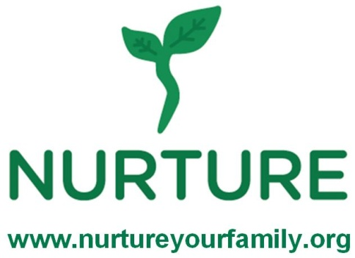
Family Program
Whole Grains and Sodium

1. I will be able to feed my family healthier foods because of this class.
Strongly agree Agree Disagree Strongly disagree

2. I feel better prepared to exercise by myself or with my family because of this class.
Strongly agree Agree Disagree Strongly disagree

3. I would recommend this program to another family: Yes No

4. One way I learned for my family to eat more whole grains is:

5. One way I learned for my family to eat less sodium is:

6. My favorite part of the session was:

7. To improve the program I would recommend:

8. What was your opinion of the food prepared today?
Recipe I didn’t like it I loved it

_______________________________________________ 1 2 3 4 5
_______________________________________________ 1 2 3 4 5
_______________________________________________ 1 2 3 4 5
_______________________________________________ 1 2 3 4 5
Comments:

