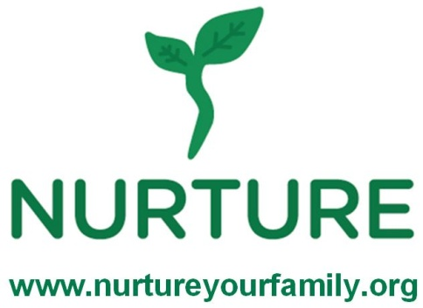
Family Program
Breakfast and Home Cooked Meals

1. I will be able to feed my family healthier foods because of this class.
Strongly agree Agree Disagree Strongly disagree

2. How often do you and/or your family eat the following foods compared to before taking these classes?
Fruit and vegetables No more A little more More Much more
Whole Grains No more A little more More Much more
Beans and lentils No more A little more More Much more

3. Are you and/or your family exercising more because of these classes?
No more A little more More Much more Comment:

4. Have you seen any changes to your and/or your families’ health or energy levels because of these classes?
No more A little more More Much more Comment:

5. How have these classes impacted you and your family?

6. Has the amount of money you spend on food changed because of these classes? How?

7. Have you changed what you serve for breakfast, lunch or dinner as a result of these classes? How?

8. What was your opinion of the food prepared today?
Recipe I didn’t like it I loved it

_______________________________________________ 1 2 3 4 5
_______________________________________________ 1 2 3 4 5
_______________________________________________ 1 2 3 4 5
_______________________________________________ 1 2 3 4 5
Comments:

